


SHOEBOPS are a symbol of OPTIMISM, HEALTH and ENERGY!!!

!

Put SHOEBOPS in your birthday goodie bags or pass them out at your next gathering –

SHOEBOPS are FOR FUN!!!

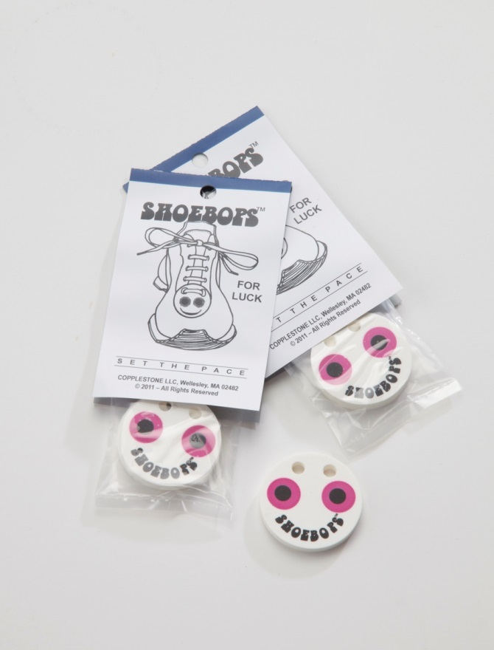

Today we all face both personal and global challenges.
Some may wear WRISTBANDS, LAPEL PINS, or RIBBONS.
Boppers put on SHOEBOPS to spread their message of
OPTIMISM, HEALTH and ENERGY.
When you wear SHOEBOPS, you wear a smile. SHOEBOPS have the seven chakra colors - one for each day of the week to symbolize: love, vitality, intelligence, knowledge, success, self-control, health, energy, wisdom, happiness, confidence, beauty, creativity, mysticism, intuition…
When you put on your SHOEBOPS, you're saying we recognize the challenges that face us every day, and we are going out to meet them with a positive, optimistic attitude.
When you see someone taken by surprise and smiling when they catch a glimpse of your SHOEBOPS,
you will know that your message has been received. Your SHOEBOPS have lightened someone's day, cheered them up - if only for a moment.
A shoelace accessory

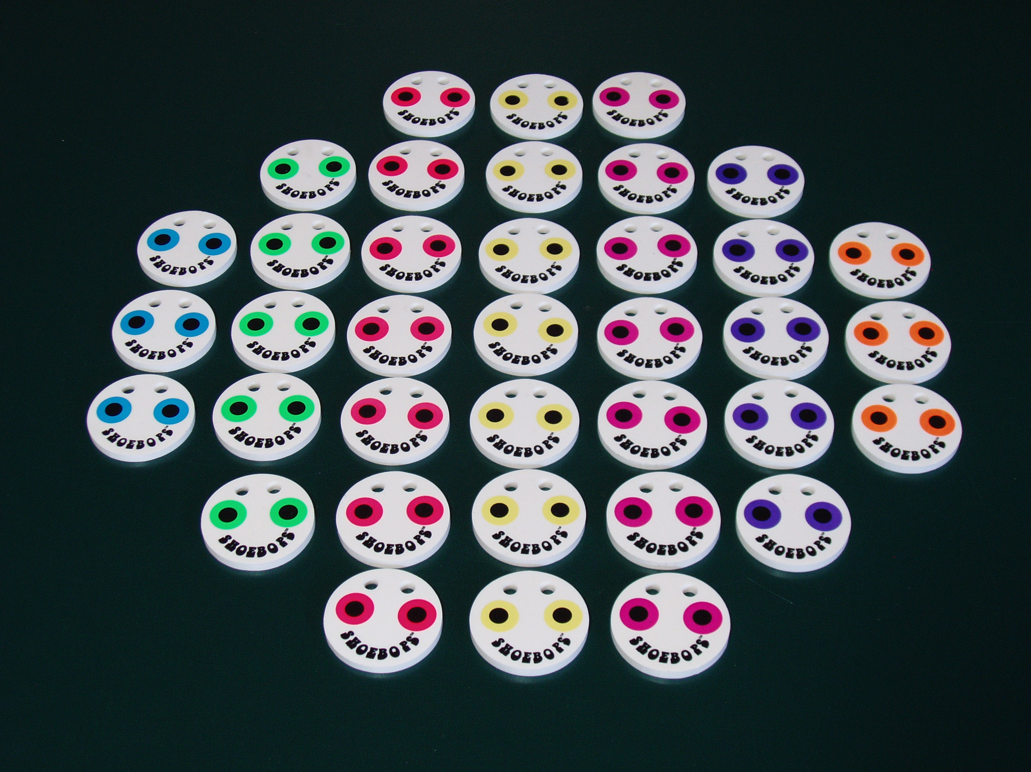
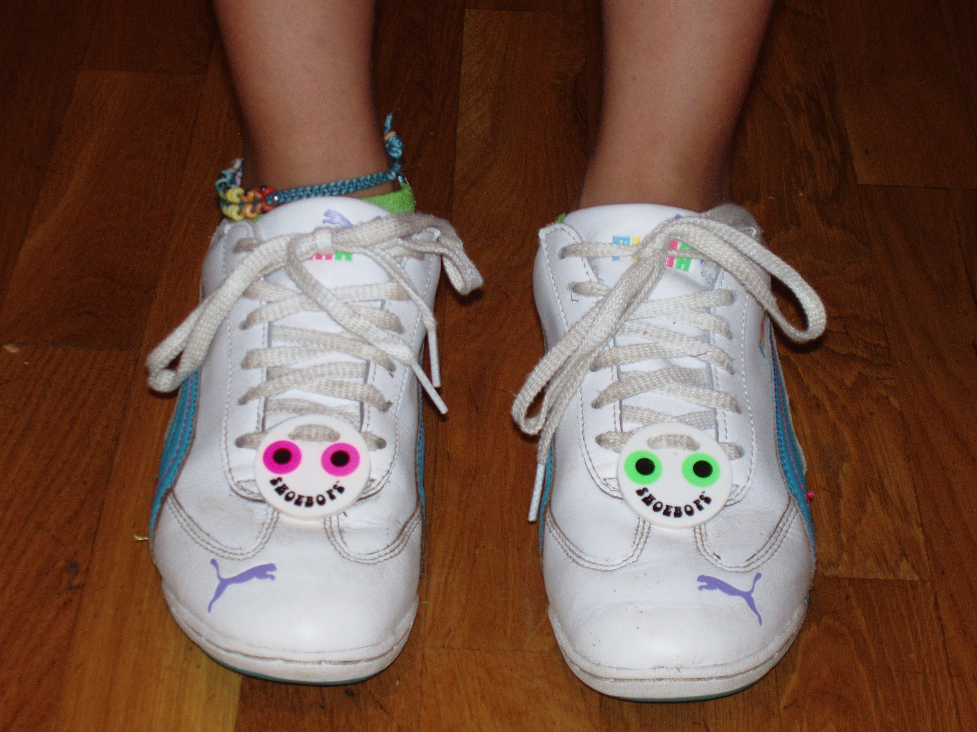
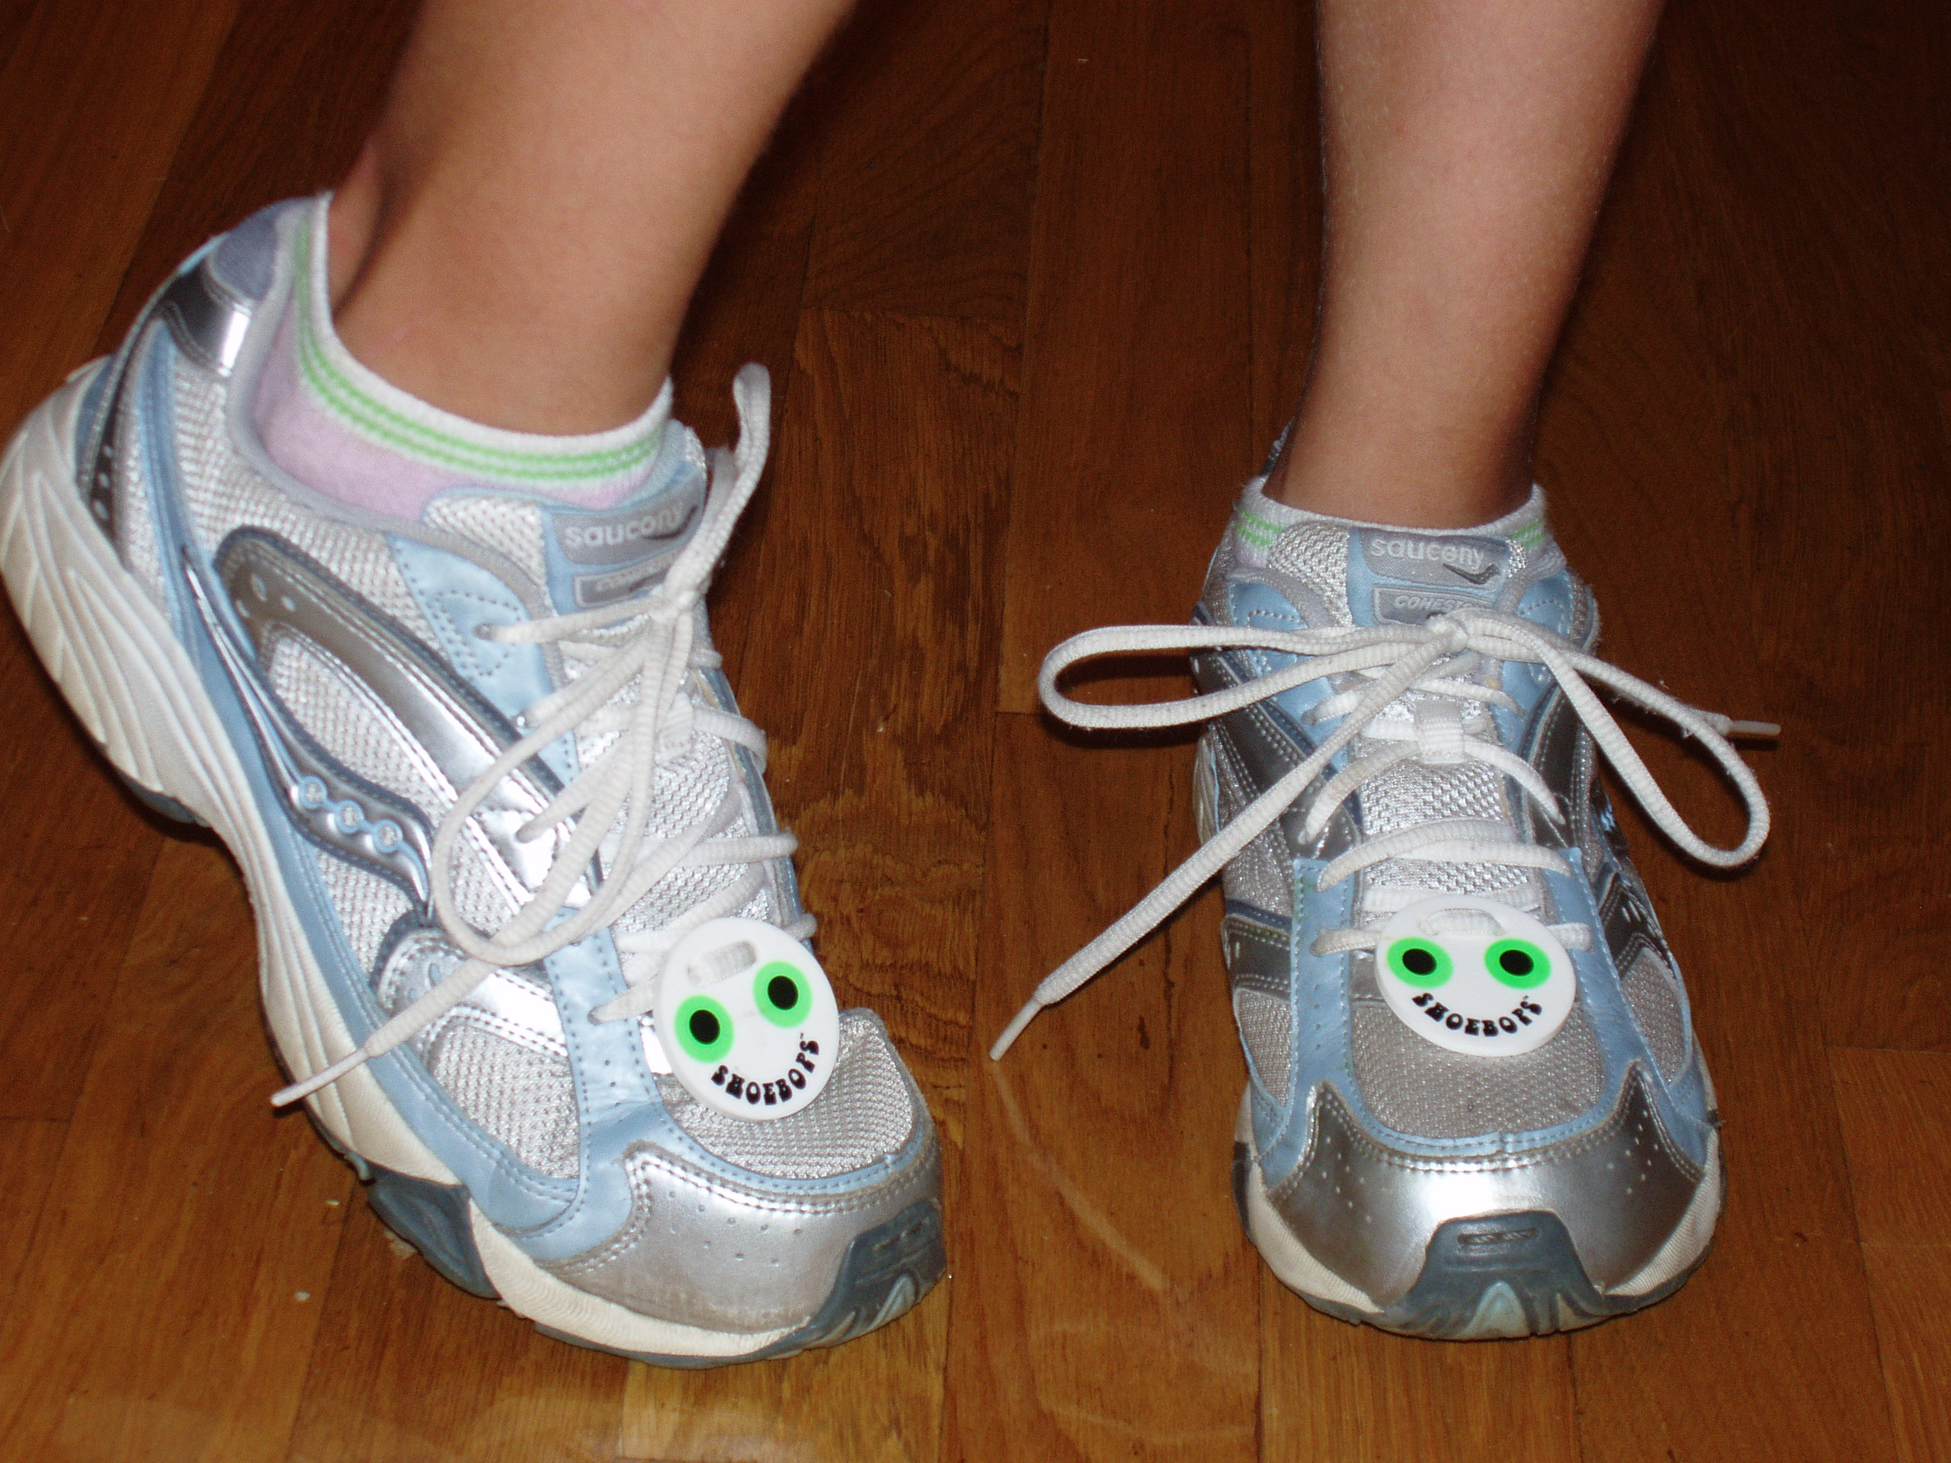

© 2026 All Rights Reserved, D.W. Copplestone, Osterville, MA 02655

Email: copplestonegames@gmail.com Web: www.shoebops.com Web.: www.copplestonegames.com

Order your SHOEBOPS today and you will quickly agree that this new shoelace accessory adds a new dimension to the shoelace accent market. This one has craze potential.

The TOUGHEST TWO FEET IN GOLF
Set the record for the least number of strokes needed to make a hole in one from each of the 18 positions indicated on the 48”x31/2”x3/4” Putting Rail.
Begin by placing the golf ball on the space marked #1. Putt the golf ball down the center of the rail and into the hole at the end of the rail. If you fail try again and again until you are successful. Mark the number of strokes taken on the regulation scorecard and proceed on to hole #2. Repeat this process until you have played each of eighteen holes in order.
Maximum ten strokes per hole.
Game score = total strokes per eighteen holes.

Consider the unique features of SHOEBOPS
Tied to a shoelace or sneaker lace they are absolutely intact, yet removable.
SHOEBOPS are moisture proof.
Designed to fill a decorative need… they have so many different uses, you’re limited only by your imagination.
We are talking about an inexpensive item! Everyone can enjoy the unique accent that SHOEBOPS provide.
The rest of the good news is that Kids Love Them!

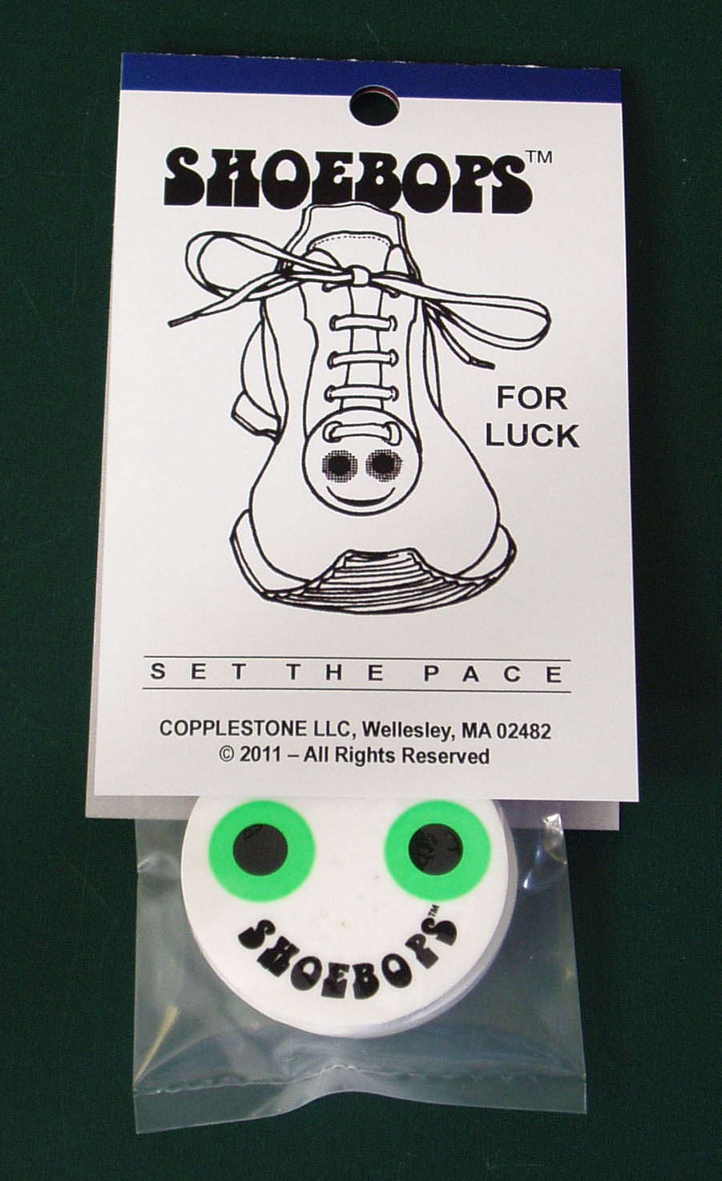

FOR LUCK, ENERGY & HEALING
Shoebops have seven chakra colors to rebalance and enhance our body’s energy centers and to
stimulate our body’s healing process.

How SHOEBOPS™ was created - by way of a children’s story:
A child dreamed they were lost on the Island of Mystery. They climbed the Mountain of Magic, high above the Lake of Luck, to see what they could see. When they reached the top, they found the wondrous Golden Pot of Perpetual Production, with an inscription that read - What will you have me produce? Feeling lost and down on their luck, they said, "something FOR LUCK would be just the thing" (with a little luck, they thought, they might find their way home). Looking up, they saw the full moon and said, "it should be round like the moon; it should be colorful and always smiling." A song, Shoebop (actually "She Bop" by Cyndi Lauper), had been playing in the child's head all that day, so they said, "it should be called SHOEBOPS, and it should be tied to your shoelaces to help you find your way." In an instant, the Pot filled with SHOEBOPS of all colors, each with special powers from the Mountain of Magic and the Lake of Luck. The child reached in and picked up one of the shoebops. Just then, all the Earth's continents joined together, and the child (with their Shoebops leading the way) followed a pathway down the Mountain of Magic and across a land bridge home. The next morning, the child woke up, rushed to their closet, and found, on their shoelaces, a moon-shaped, colorful, always-smiling, lucky pair of SHOEBOPS!!! David Copplestone - the big bopper

A shoelace accessory

Order your SHOEBOPS today and you will quickly agree that this new shoelace accessory
adds a new dimension to the shoelace accent market. This one has craze potential!

Ages 7 and up

© 2026 All Rights Reserved, D.W. Copplestone, Osterville, MA 02655

Email: copplestonegames@gmail.com Web: shoebops.com Web: copplestonegames.com

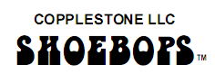



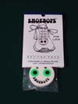 | Description: 1 UNIT - 2 Shoebops per unit  Unit Cost: $10.00  Each: $10.00  Shipping:  Ages 7 and up  Available in Blue, Green, Red, Yellow, Violet, Indigo, and Orange | 
  Choose Color
  
 | Description: 2 UNITS - 2 Shoebops per unit  Unit Cost: $10.00  Each Pair: $20.00  Shipping:  Ages 7 and up  Available in Blue, Green, Red, Yellow, Violet, Indigo, and Orange
  Choose Color
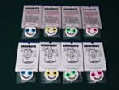 | Description: Box - ASSORTED PACK - 14 Units, 2 units of each color  Unit Cost: $ 7.00  Each Box: $98.00  Two each - Blue, Green, Red, Yellow, Violet, Indigo, and Orange
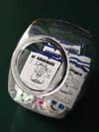 | Description: CASE - 84 units - 6 Boxes - (12 units of each of seven colors per case)  Unit Cost: $ 6.00  Each Case: $540.00



SHOEBOPS ADOPTED THEME SONGS
She Bop - YouTube  Cyndi Lauper Video | Who put the bomp  in the bomp bomp bomp - You Tube  Barry Mann

 | 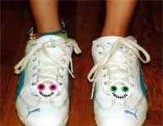 | 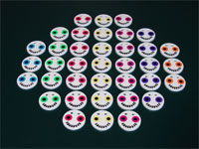

A very special collectible from the esteemed COPPLESTONE COLLECTION.
PRODUCT REPLENISHMENT
UPDATED COSTS / COMING SOON
 Sales Order
COPPLESTONE LLC
Osterville, MA 02655 U.S.A. Customer Service (781) 223-6516
E-mail copplestonegames@gmail.com www.shoebops.com www.copplestonegames.com copplestoneartworks.com

_____________________________________ ____________________________________
Sold To Ship To
_____________________________________ ____________________________________
Address Address
_____________________________________ ____________________________________

_____________________________________ ____________________________________
City State Zip City State Zip
____________________________________________ ___________________________________________

Telephone # __________________________ Account # ___________________________

QTY. | Model # | Description | Unit Price  Wholesale | Amount
 | CG0022SB | SHOEBOPS – one pair per unit - Vinyl 1.5” round | $10.00
 | CG0022SB-  Envelope | SHOEBOPS – two units per shipping envelope –  shipping envelope 5”x3”, weight 2 oz. | $16.00  $8.00 each
 | CG0022SB-  Box | SHOEBOPS – 14 units per box – two of each of seven colors per box - box 6”x3”x3”, weight 1 lb. | $98.00 $7.00 each
 | CG0022SB-  Case | SHOEBOPS – 84 units per case – 6 boxes per case,  12 units of each of seven colors per case.  Case box 12”x6”x6” – weight 6 lb. | $504.00  $6.00 each
 | CG0022SB-  Master carton | SHOEBOPS – 1,008 units per case,12 cases per master carton, master carton 24”x18”x12” – weight 72 lb. | $4,032  $4.00 each
 |  | Costs are under review to establish our most affordable pricing. Updated costs coming soon.

New Account Old Account Date ________________

Order # _______________________ Dept. # _______________________

SALESPERSON: _____________________________________________________________

Invoice # ________________________

AUTHORIZED SIGNATURE ___________________________________________________

